PROFILE OF INSTRUCTORS/LIBRARY STAFF/NON-TEACHING STAFF
Annexure-II
HARI OM SHIV OM COLLEGE OF EDUCATION
Vill. ChhotaBaans, Radaur, Distt. Yamuna Nagar -135133
S.No. | Name & Full Address | Designation | Qualification | Letter No. and Date of  University Approval | Date of Joining | Nature of  Employm  ent | Pay Scale | ID Number
1 | Mr. Suresh Kumar Kaushal,  #432/1, Babain Road,  Ladwa, Kurukshetra | Head Clerk  Adm.Officer | M.Com |  | 8/11/2010 | Regular | 9300-34800 | 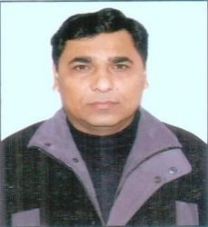
2 | MRS. PARUL KAMBOJ W/O SH. MUNIT KAMBOJ VOP CHAMRORI, DISTT. YAMUNA NAGAR | LIBRARIAN | B.LIB. , M.LIB | CBA/A151/2019/18744 | 15/09/2019 | Regular | 9300-34800 | 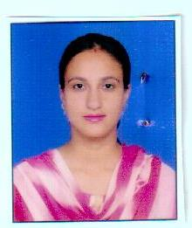
3 | Mr. Vinod Kumar, V.P.O.  Bakana, Yamuna Nagar | Office cum account Assitt. | B.A |  | 19/04/2010 | Regular | 9300-34800 | 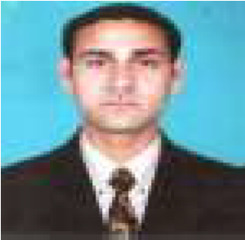
4 | Mrs. Raj Rani | Technical Assistant | M.A |  | 17/08/2026 | Regular | 9300-34800 | 
5 | Mr. Gurdip Singh | Lab Attendant | B.Sc. Sports |  | 01/06/2026 | Adobe | 9300-34800 | 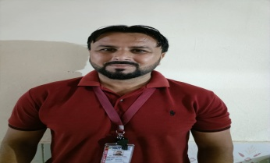
6 | Mr. Sahil Kumar VPO Dohali, Dist. Yamunanagar | Lab Attendant | 12th |  | 01/12/2019 | Regular | 5200-20200 | 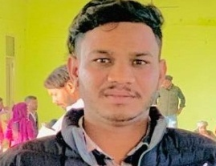
7 | Mrs. Amita VPO Khedi Dabdalan  Dist. Kurukshetra | Helper | 10th |  | 01/02/2020 | Regular | 5200-20200 | 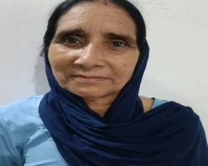
8 | Mrs. Meenu VPO Radaur  Dist. Yamunanagar | Helper | 12th |  | 15/09/2026 | Regular | 5200-20200 | 