PROFILE OF QUALIFIED AND APPROVED TEACHING FACULTY
HARI OM SHIV OM COLLEGE OF EDUCATION
Annexure-1
Vill. ChhotaBans,Radaur ,Distt.YamunaNagar,Haryana -135133
(Course:B.ED.)
S.No | Name &Full Address | Designation | Qualification | Letter No. and Date of University Approval | Date of Joining | Nature of Employment | Pay Scale | ID
1 | Dr. Dilip Kumar Jha,H.No. 4/2325,gali no.5,Bihari colony ,(Near InderPalace)Shahadara,Delhi-32. | Principal | M.A(Skt.)  M.A(Hindi)  B.ED,M.Ed.,Ph.D | CBA/A-151/2012/8743  Dated 27.4.2012 | 13/04/12 | Regular | 37400-67000 | 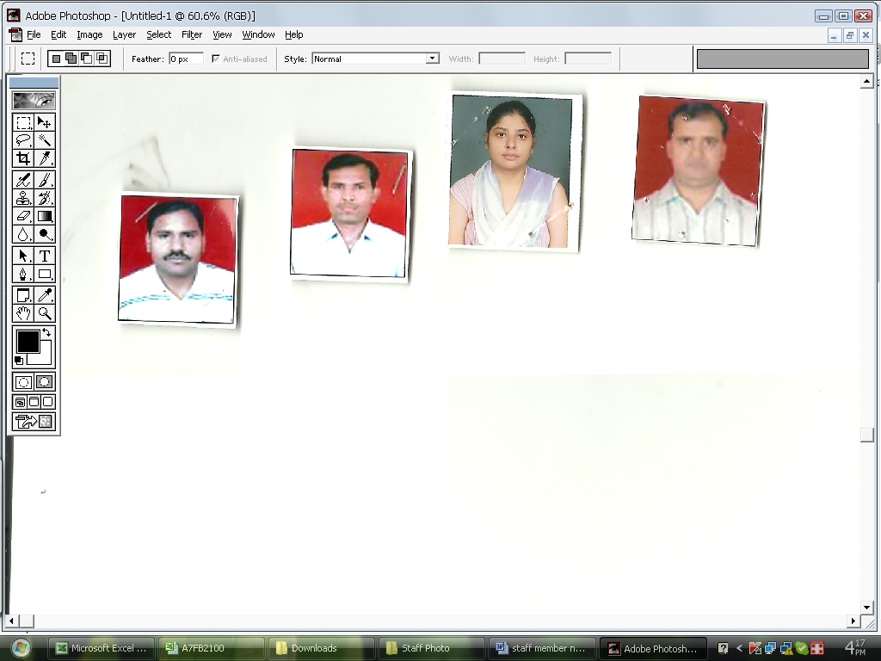
2 | Dr. PROMILA RANI D/O Sh.SHIV DAYAL PAL SEC. 02 KKR | Assistant Professor in Pedagogy of Hindi | B.ED,M.ED,M.P.HILL | CBA/A151/2012/201642  DATED -22-10-2012 | 23-07-2012 | Regular | 15600-39100 | 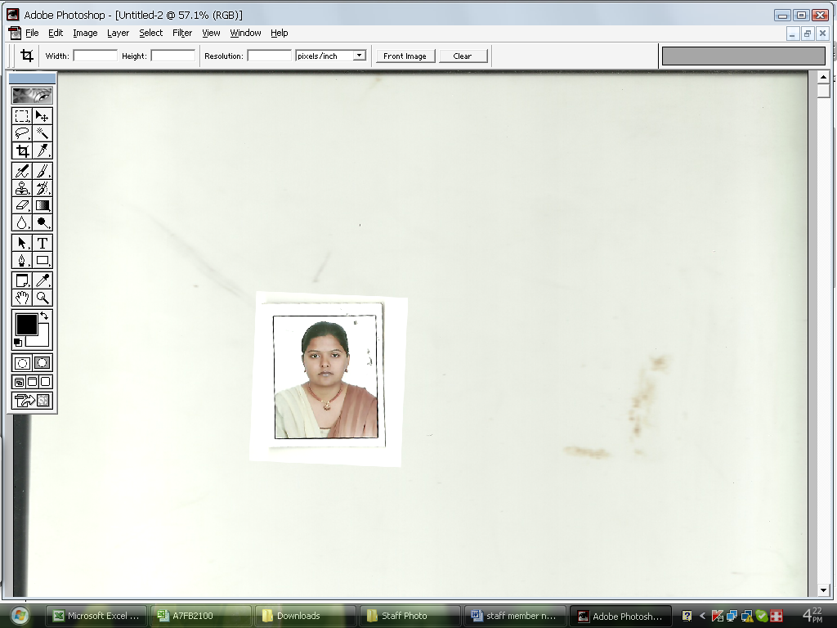
3 | MS. MAMTA RANI D/O SH. RAM RAJ YADAV#C-7/456,ROOP NAGAR COLONY JAGADHRI DISTT YAMUNA NAGAR-135133 | ASSTT. PROF IN TG.OF ENGLISH | M.ED,NET | CBA-A151/2013/10868  DATED 07-06-2013 | 02-11-2012 | Regular | 15600-39100 | 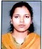
4 | MS. MANJU DHIMAN D/O SH. HARISH CHAND DHIMAN R/O MANOHARPUR NEAR SEASONS BENGUL HALL DELHI ROAD SAHARNPUR | ASSTT. PROF IN TG.OF ART | B.ED,M.ED | CBA/A151/2014/15471  DATED-24-07-2014 | 24-07-2014 | Regular | 15600-39100 | 
5 | MR. PARVEEN KUMAR S/O SH. RADHE SHAYAM R/O 468 NEAR SURYANSH GAS AGENCY HARIDWAR JHABRERA,UK-247665 | ASSTT. PROF IN TG OF SOCIAL SCIENCE | M.A (POL.SCI.),M.ED ,NET EDU. | CBA/A151/2019/18744  DATED-04-11-2019 | 01-08-2019 | Regular | 15600-39100 | 
6 | MR.VAKEEL AHAMAD S/O SH. MOH.HASAN VPO-GRAM KOTA DISTT.SHARANPUR,UP-247342 | ASSTT. PROF IN TG OF LIFE SCIENCE | M.SC(BOTANY).,NET EDU. | CBA/A151/2019/18744  DATED-04-11-2019 | 01-08-2019 | Regular | 15600-39100 | 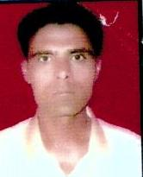
7 | Mr. AMRISH KUMAR S/O Sh. Ramesh chand VILL. CHHAPAR POST. SIRSAKA ,NAKUR.UP-247342 | ASSTT. PROF IN EDUCATION | M.ED. NET EDU. | CBA/A151/2019/18744 | 01/08/2019 | Regular | 15600-39100 | 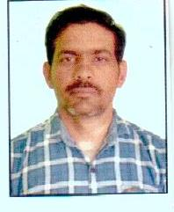
8 | Mr. Promod Kumar S/o Sh. Som Singh  VPO Gandwada  Distt. SaharanPur  Uttar Pradesh-247662 | Assistant Professor in Pedagogy of Hindi | B.ED,M.ED,M.A HISTORY,M.A HINDI,NET IN EDU. | CBA/A-151/2019/18744  DATED-04-11-2019 | 01-08-2019 | Regular | 15600-39100 | 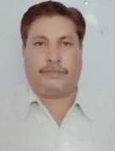
9 | Mr.Prabhat Kumar S/o Sh. Nakli Ram  R/oVPOBaggaKheriDistt.SaharanPur  Uttar Pradesh-247451 | Assistant Professor in Pedagogy of Mathematics | M.A(EDU),M.ED,B.ED,NET | CBA/A-151/2019/18744  DATED-04-11-2019 | 01-08-2019 | Regular | 15600-39100 | 
10 | MR. SUBASH CHANDRA GAUTAM  S/O SH. RAM DULAR GAUTAM  VILL. & POST. –SURERI  DISTT. – JAINPUR  UP-222203 | ASSTT. PROF IN PEDAGOGY OF SOCIAL SCIENCE | B.ED,M.ED,M.PHILL,NET | CBA/A51/2020/23706  DATED-20-01-2020 | 01-12-2019 | Regular | 15600-39100 | 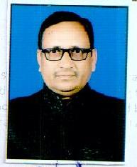
11 | MR. UMESH CHANDRA YADAV  S/O SH. DWARIK PRASAD YADAV  VILL.&POST ARTHVA SARISVA,  DISTT. AMBEDKAR NAGAR,  UP-224151 | ASSTT. PROF. IN TG OF SOCIAL SCIENCE | M.ED,B.ED,MA,NET | CBA/A51/2020/23706  DATED-20-01-2020 | 01-12-2019 | Regular | 15600-39100 | 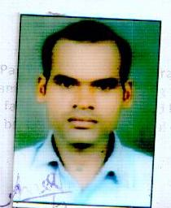
12 | MR. SATYENDRA KUMAR  S/O SH. RAJESH KUMAR  #1596 GALI NO. 3A,  RAJA KA BAGH MAINPURI,  UP-  PH. - 8937030428 | ASSTT. PROF IN TG OF MATHEMATICS | B.ED,M.ED,M.SC,NET | CBA/A51/2020/23706  DATED-20-01-2020 | 01-12-2019 | Regular | 15600-39100 | 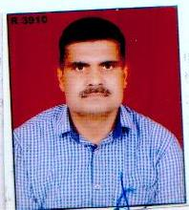
13 | MR. ABHAY KUMAR SINGH  S/O SH. PREM SAGAR SINGH  VILL. MAHUWARI,  POST. RENDA  DISTT. AZAMGARG  UP- 276204  PH. NO.- 9936542844, 9452789741 | ASSTT. PROF IN EDUCATION | B.ED,M.ED,M.A,NET | CBA/A51/2020/23706  DATED-20-01-2020 | 01-12-2019 | Regular | 15600-39100 | 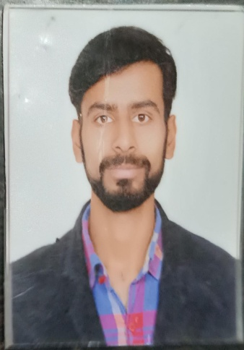
14 | MR. VIJAY KUMAR  S/O SH. PREM CHAND  MHO- SARAI KALE KHAN , NUNER GATE  POST- JAIGANJ Regular  DISTT.- ALIGARH  UP-202001  PH.- 8273889801, 9997731900 | ASSTT. PROF IN TG.OF ENGLISH | B.ED,M.ED,M.A,NET | CBA/A51/2020/23706  DATED-20-01-2020 | 01-12-2019 | Regular | 15600-39100 | 
15 | MR.ANIL KUMAR VERMA S/O SH.PALTOO RAM VERMA V.P.O MILLO,DISTT.-BASHTI,UP-272124 | ASSTT. PROF IN TG OF LIFE SCIENCE | M.SC.,NET EDU. | CBA/A51/2020/23706  DATED-20-01-2020 | 01-12-2019 | Regular | 15600-39100 | 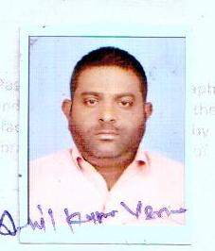
16 | Mr. BHOOPENDRA SINGH NIRANJAN S/O SH. MOLI LAL 2552 KHAJOOR BAGH NEAR BADIBIDGRH, JHASHI ,UP 284001 | ASSTT. PROF IN TG OF PHY.SCIENCE | M.Sc. PHY. M.Ed, NET | CBA/A51/2020/23706  DATED-20-01-2020 | 01-12-2019 | Regular | 15600-39100 | 